SKILL-5B
Code:
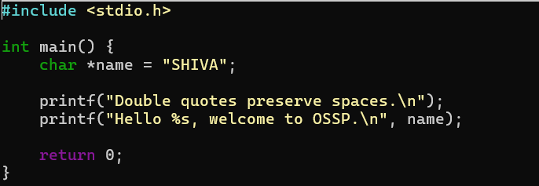

OUTPUT:
